**Configuring a Proxmox Backup Server:**

**Purpose:**

To backup the main Proxmox Server VMs so they can restore if they fail

**Scope:**

Applies to the IT team and system administrators

**Requirements:**

* A good internet connection
* A physical server (can also be done on a virtual hypervisor)
* A bootable USB with minimum 32 GB RAM

**Process Overview:**

Part 1 – Downloading Proxmox Backup Server iso and making a bootable drive

Part 2 – Installing Proxmox Backup Server

**Process Setup:**

**Part 1 - Downloading the Proxmox Backup Server iso and making a bootable drive:**

**Step 1:** On a local browser, search up **proxmox backup server iso download** and click the Proxmox website:

**Step 2:** On the Proxmox site, choose the latest Proxmox Backup Server version and click **Download:**

Wait for the Backup Server iso to download:

**Step 3:** Back on a local browser, search up **rufus download** and click the rufus website link:

**

**Step 5:** Wait for the download to complete and click **Open file:**



**Step 6:** Plug the USB drive into the computer:

**Step 7:** On the rufus-49.exe media, make sure the boot selection option is on **iso or bootable media** and click **select**

**Step 8:** Choose the Proxmox Backup iso we downloaded earlier:



When selecting the iso, click **Ok** when prompted with the ISOHybrid image warning:

**Step 9:** On the rufus.49 media, review the defaults and when ready, click **Start**

**WARNING: This will destroy ALL the device files. Make sure the USB is empty before configuring**

**Step 10:** When the **Location is not available** prompt displays the bootable media is ready. Click **Ok** and eject the **bootable USB:**

**Step 11:** Unplug the USB from the computer:

**Step 12:** Insert the USB into the server:

**Step 13:** Boot up the server and wait for the installer page to display

**Part 2 – Installing Proxmox Backup Server**

**Step 2:** Review the EULA agreement and click **I agree:**

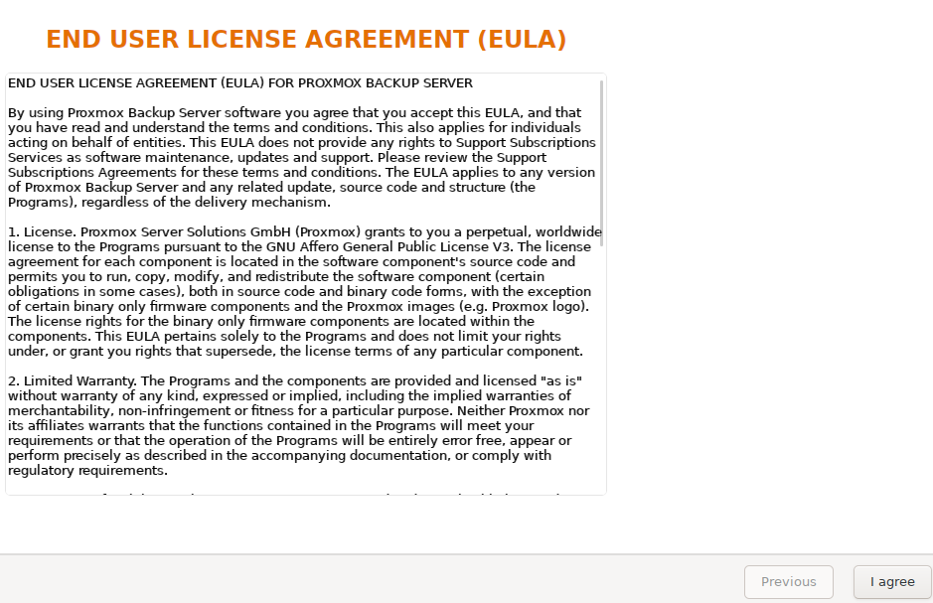

**Step 3:** Leave the default hard disk, **click Next:**



**Step 4:** Choose your country and time zone. Click **Next:**

**Step 5:** Enter a memorable password and a vail email address, click **Next:**

**Step 6:** Enter a vail FQDN. Then enter in an ip address, default gateway, and DNS server of your choosing. Once ready, click **Next:**

**Step 7:** Review the summary page, when ready **click Install:**



Wait for the installation to complete:

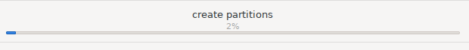

Once finished, click **Reboot:**



**Step 8:** Using the address configured earlier, access the Proxmox Backup Server using a browser tab:

